**MYP Geography Year 11 Practice paper**

**Answer all the questions.**

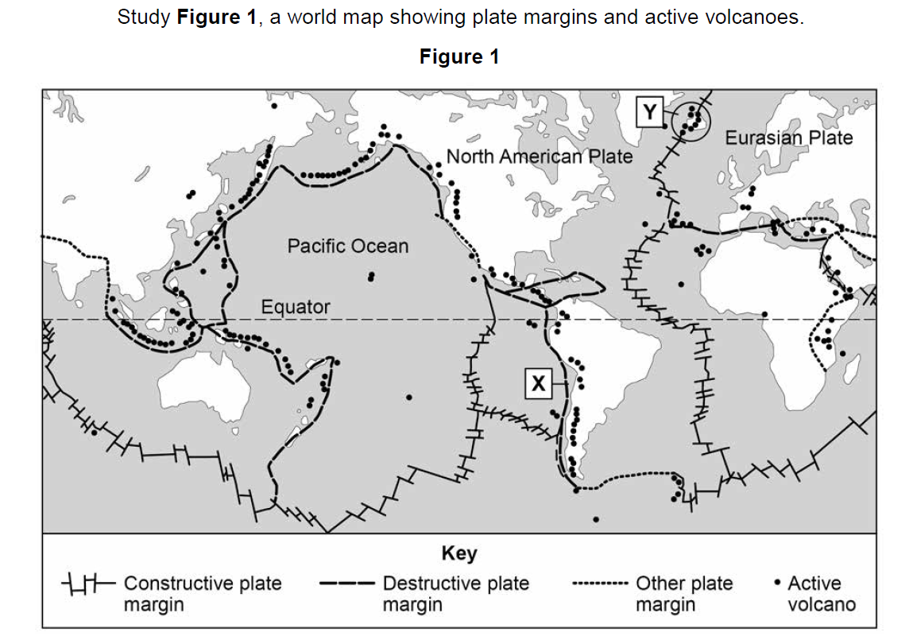 Over the next few days, starting March 22 to 25, you will attempt these Criteria A, C and D questions during your e-portfolio periods assigned for I&S (Sunday-period 1, Tuesday period 1 and Wednesday period 1).

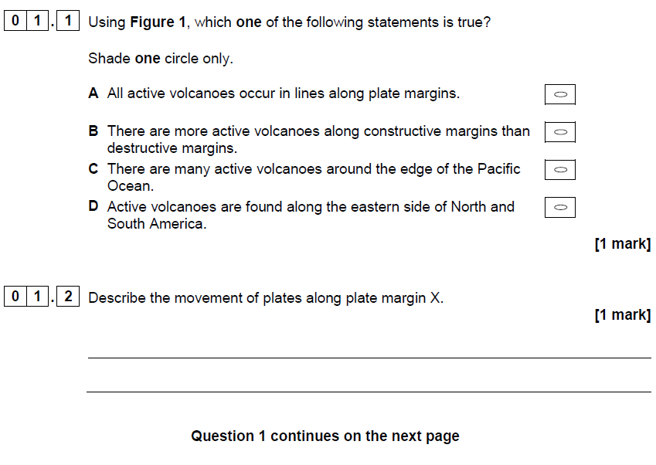

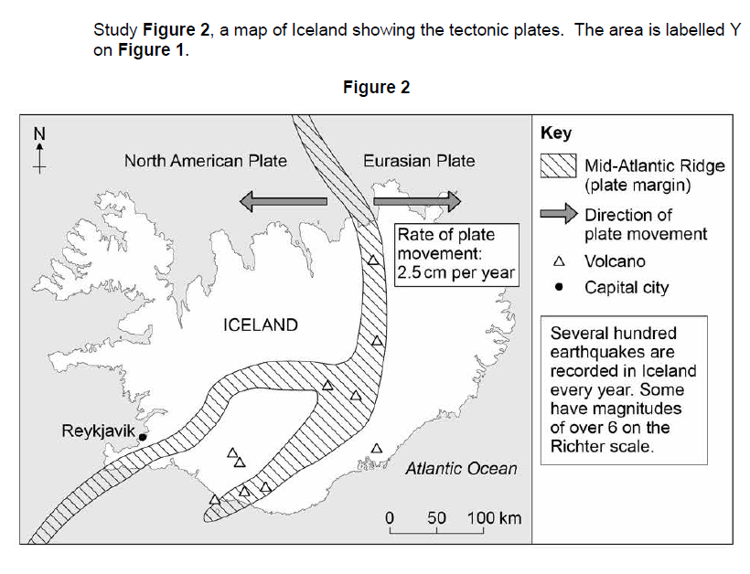

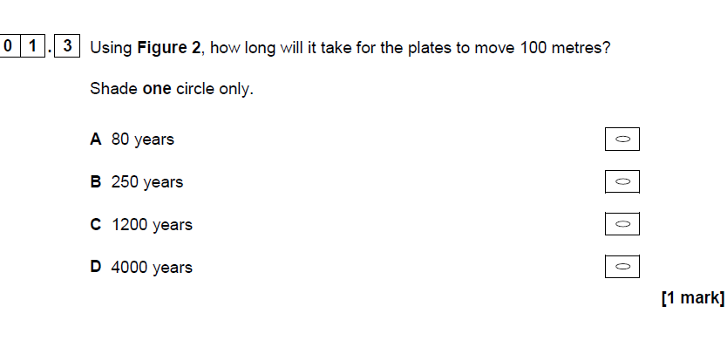

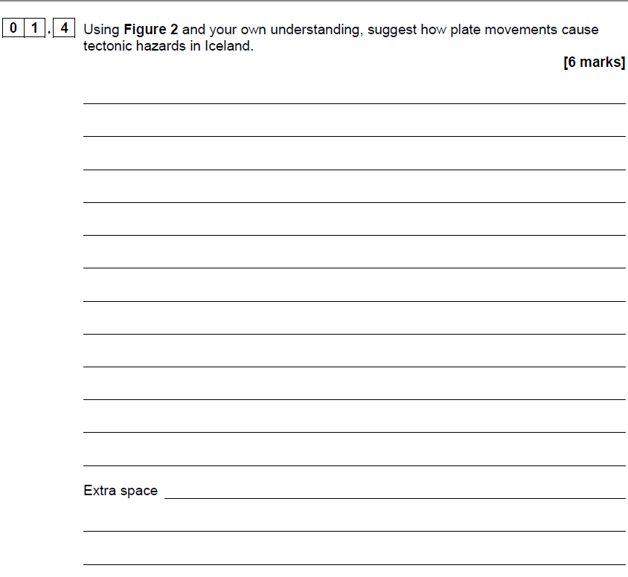

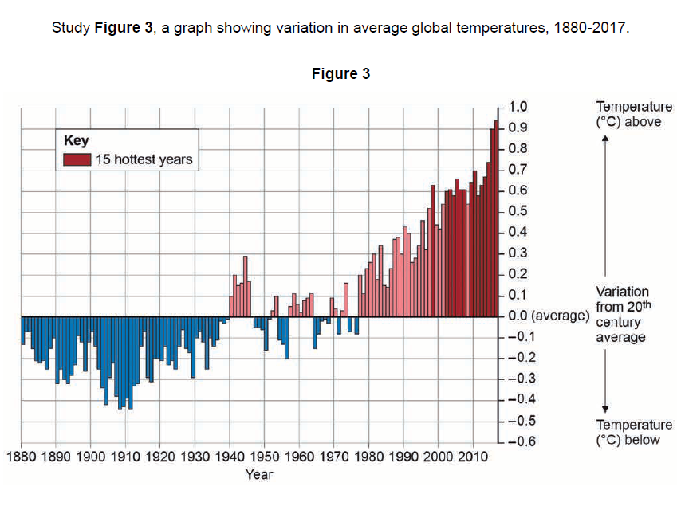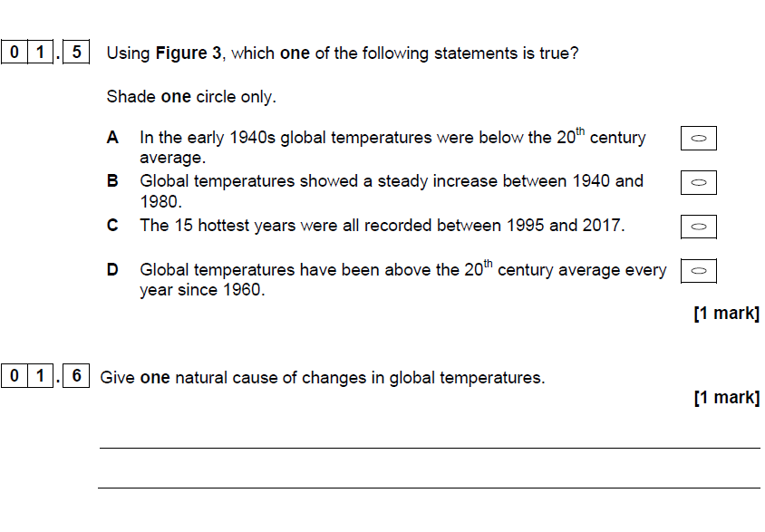

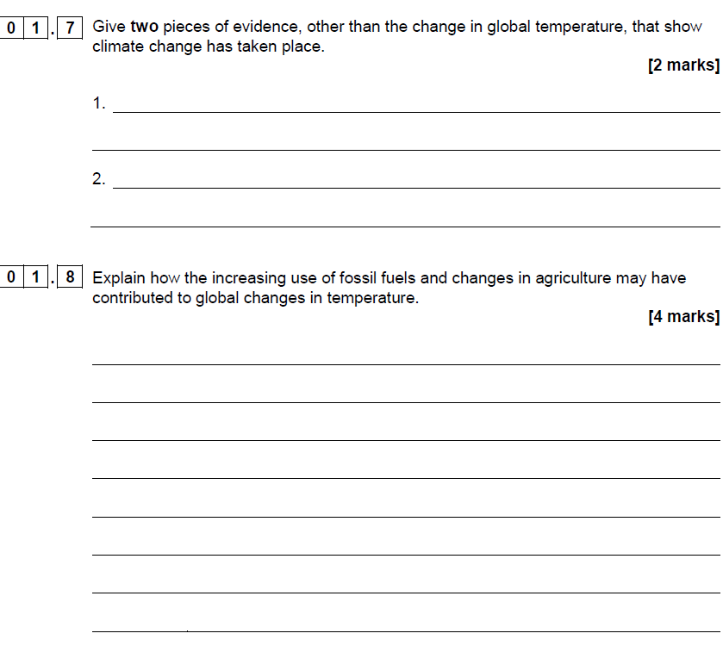

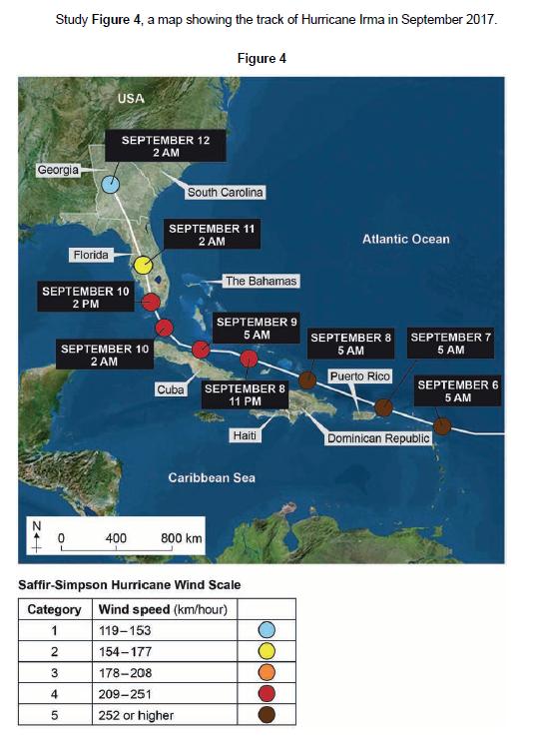

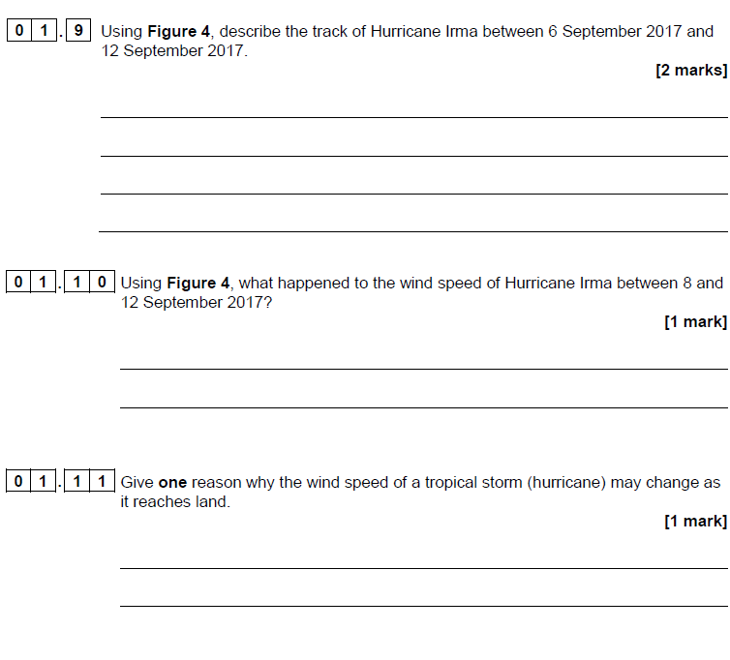

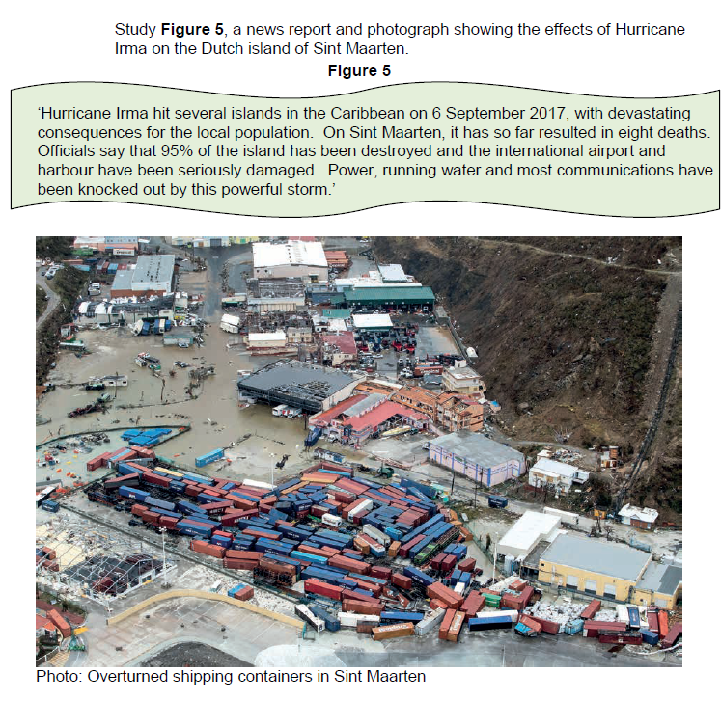

1. 1 2 Assess the extent to which tropical storms or any other natural disaster has effects on people and the environment. **[12 Marks]**

**_________________________________________________________________**

**_________________________________________________________________**



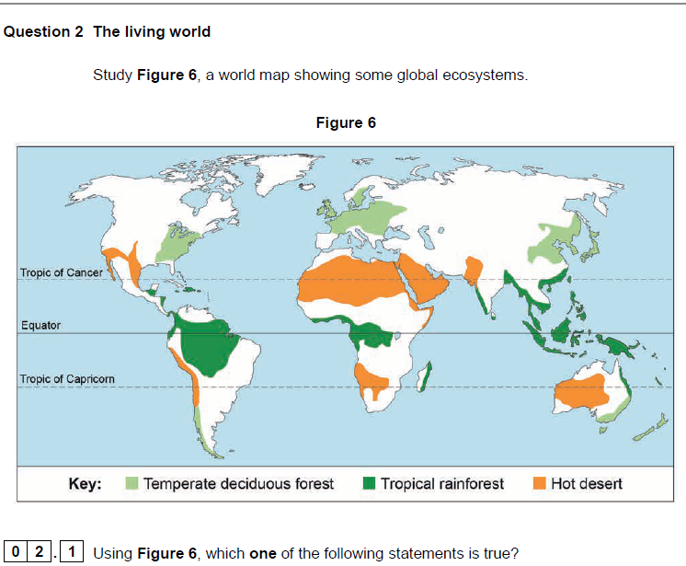

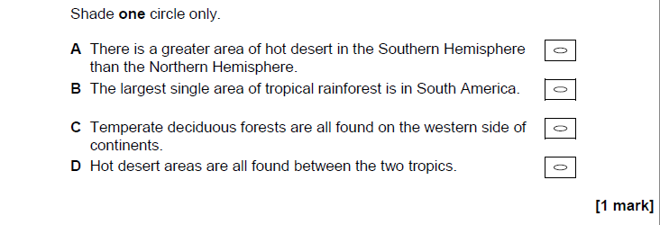

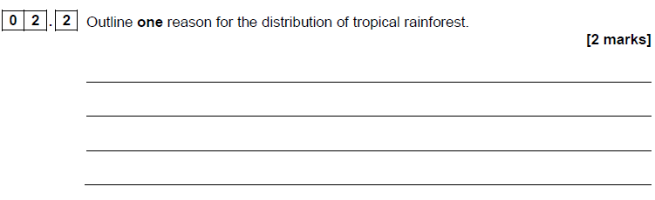

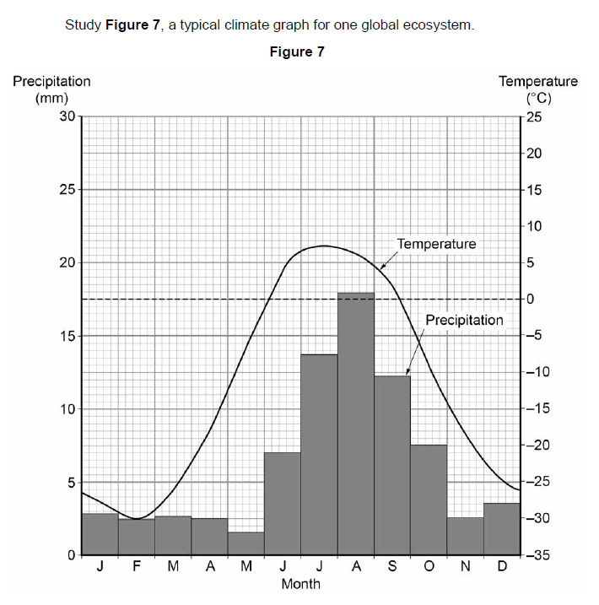

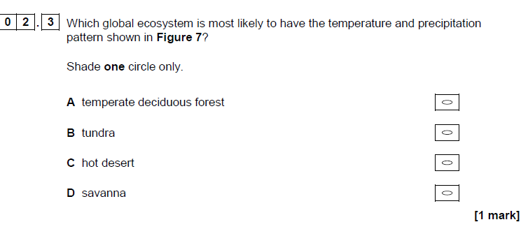

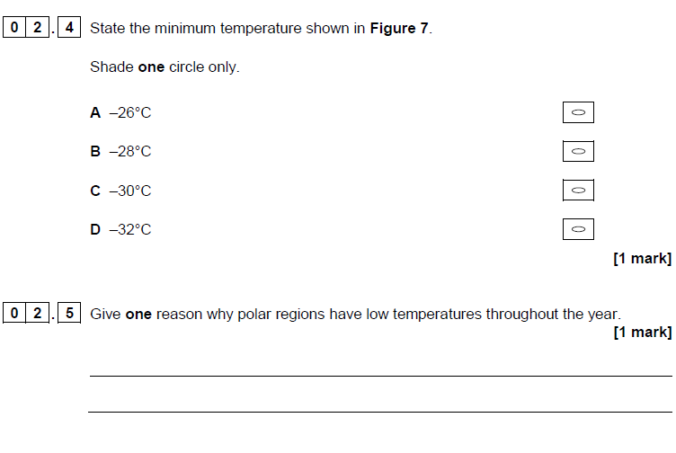

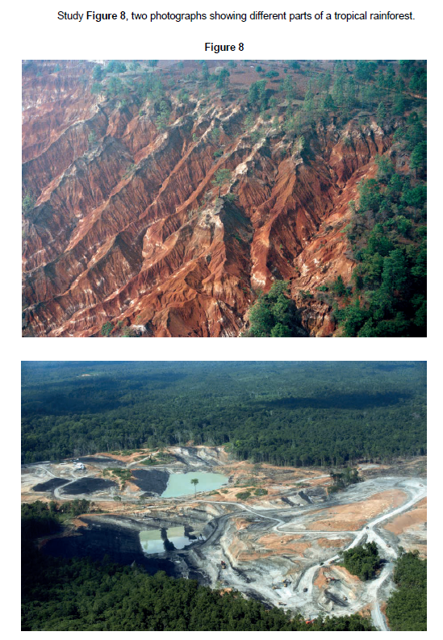

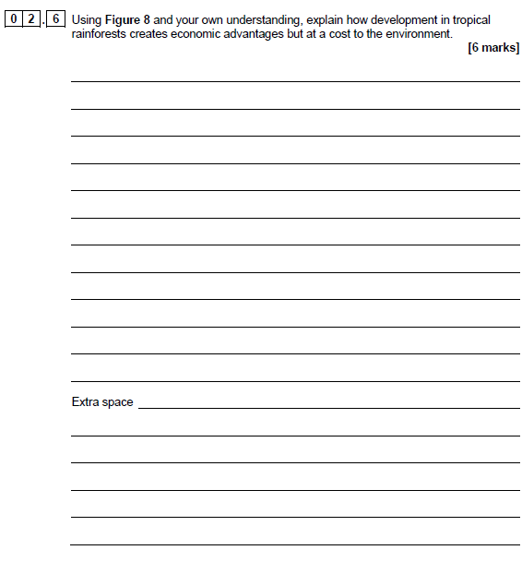

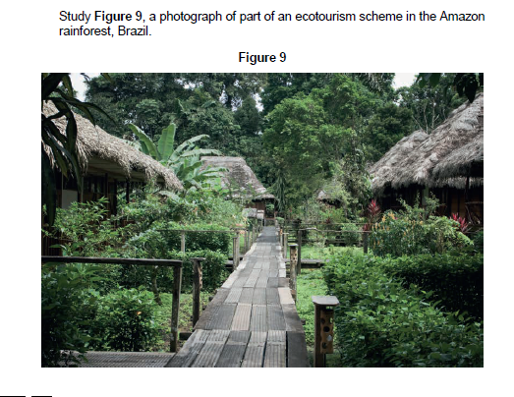

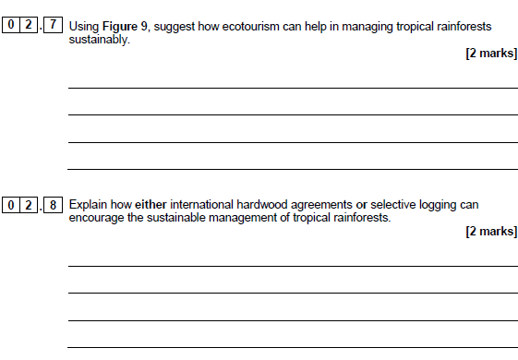

02.9 In a letter to the editor of a local newspaper, explain how deforestation provide both opportunities and challenges. In your essay you must refer to:

* Examples from your MYP studies
* Refer to social, economic and environmental impacts
* Consider the Global context of *Identities and relationships*. [24 marks]

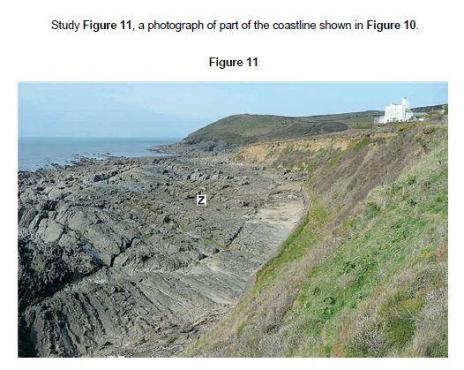

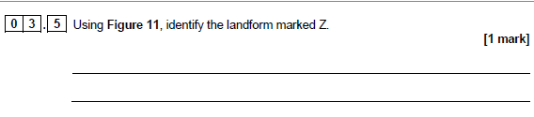

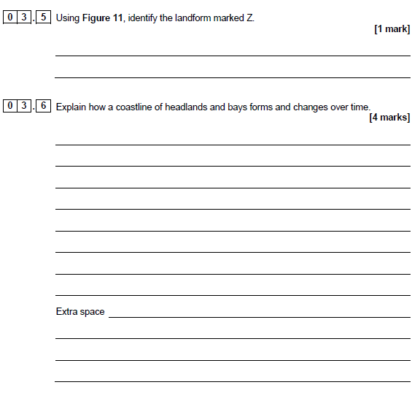

03.7 Coastal management strategies are effective in protecting the coastline from coastal process. Evaluate the statement in a well-structured essay. In your essay you must refer to examples or case studies from your MYP studies. [24 marks]

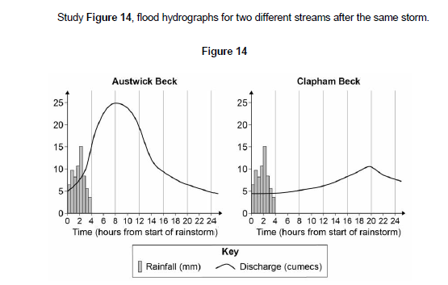

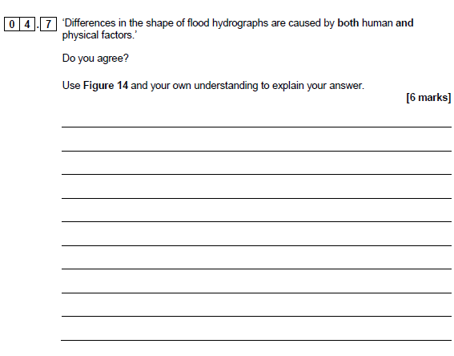

05.1 A local TV channel has asked to interview you.

Your interview should persuade people to sign your petition by explaining how natural environments are threatened by tourism and how they could be managed more sustainably.

In your response you must refer to examples from your MYP studies. [20 marks]